5.
9.
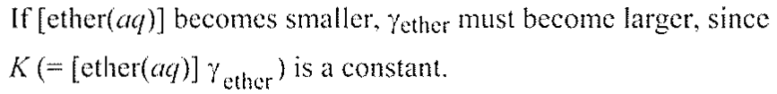
13.
활동도를 무시할 경우 pH = -log(0.010) = 2.00
14.
21.
20.
26. [H⁺] = 1.08 x 10⁻¹¹ M, [NH₄⁺] = 9.29 x 10 ⁻⁴ M, [OH⁻] = 9.29 x 10 ⁻⁴ M, and [NH₃] = 4.91 x 10⁻² M; pH = 10.97 and fraction of hydrolysis = 1.86%
29.

34.

